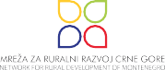
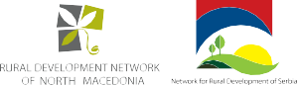

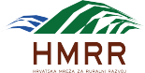
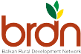
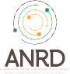
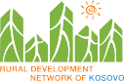
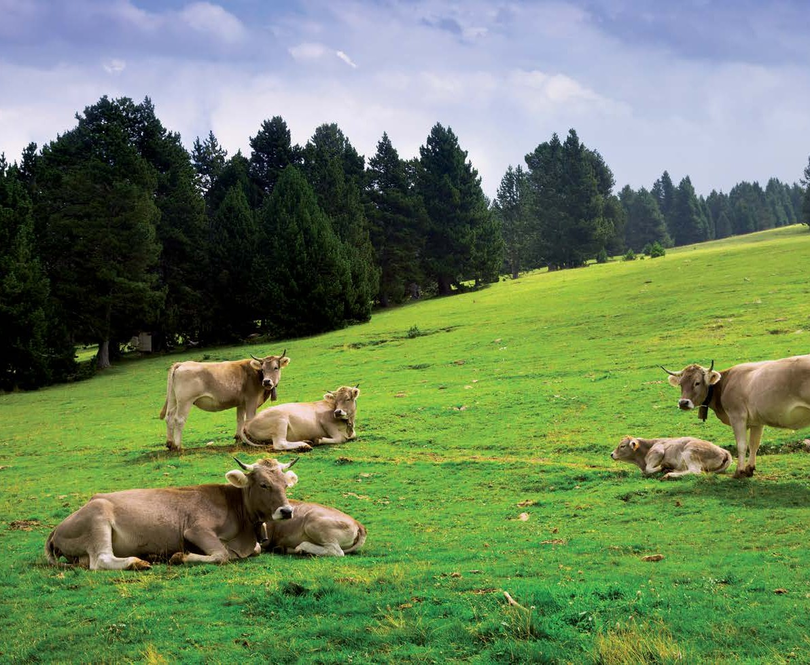
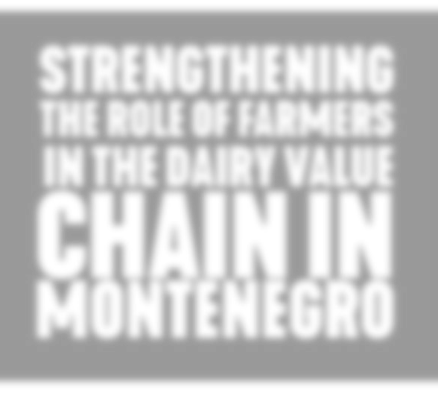


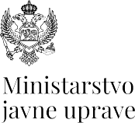

2

Contents
- Summary 4
- Introduction 5
  - State and importance of agriculture in Montenegro 5
  - The purpose of the analysis 6
- Data collection and processing methodology 7
  - Criteria for the selection of the value chain 7
  - Dairy value chain 8
  - Stakeholder consultation 10
- Results and discussion 12
  - Participants’ responses and comments on the proposed topics 12
  - Proposals and suggestions from workshops’ participants 13
  - SWOT analysis 14
- Conclusions 15
- Recommendations based on the SWOT analysis 16
- Messages from the Conference, at which the National report was presented 17
Reference 18
Annex I
Photo documentation from the workshops 19
- Consultative workshop in Nikšić, November 6th 2024 ..............................................................20 3
- Consultative workshop in Tuzi, November 7th 2024 20
- Consultative workshop in Nikšić, November 8th 2024 21
- Consultative workshop in Danilovgrad, November 11th 2024 21
- Consultative workshop in Bijelo Polje, November 12th 2024 22
Annex II
National Conference - photo documentation and media coverage 23

Summary

As a part of the document “Strengthening the role of farmers in the dairy value chain”, a qualitative process of consultation and dialogue with producers/farmers as well as with interested parties was car- ried out in order to identify the challenges that relevant actors face in the era of green transition and to influence the strengthening of the position of farmers in the dairy value chain in Montenegro through the proposed measures and policies.
Chapter 2 gives a brief overview of the situation in agriculture and its importance in Montenegro, while chapter 3 presents the methodology and criteria for the selection of the value chain, as well as the reasons that determined it would be milk production as it is the dominant activity in the livestocks sector in Montenegro.
Chapter 4 presents the key challenges faced by milk producers as well as their suggestions for improving the situation, obtained through workshops held in 4 municipalities in Montenegro (Nikšić, Danilovgrad, Tuzi and Bijelo Polje). There is also a SWOT analysis done by a consultant in order to additionally identify external and internal factors that affect the dairy value chain in Montenegro.
In chapter 5, the key recommendations for improving the situation of the farmers obtained as a result of the value chain analysis are given, grouped as follows:
- Strengthening the cooperation of milk producers
- Improving cooperation in the value chain and solving bad trade practices
- Development of market-oriented production models
- Monitoring and application of research and innovation.
4 Chapter 6 presents the recommendations based on the SWOT analysis, which are grouped as follows:

- Recommendations to farmers and
- Recommendations to competent institutions and interested parties.
Chapter 7 contains key comments and recommendations from the Conference, at which the national report was presented and which was organized by Network for Rural Development of Montenegro in Nikšić, on December 23, 2024.

Introduction

The regional project “Farm to Fork Academy for Green Western Balkans – Our shared European future”, which is financially supported by the European Union, is jointly implemented by the NRDN family in six countries of the Western Balkans (Albania, Bosnia and Herzegovina, Kosovo, Montenegro, North Macedonia, Serbia), as well as Croatia and the joint platform for regional cooperation, the Balkan Net- work for Rural Development (BRDN). The project focuses on the implementation of the process of EU integration and rapprochement in the WB countries in the sector of agriculture and rural development through the promotion of a green and fair transition in the region through the contribution of civil society actors.
Within this project, a qualitative process of consultation and dialogue of interested parties is carried out, which seeks to collect inputs from small agricultural producers and their associations and other rural actors in order to identify the challenges that the relevant actors face in the green transition and the key success factors that accelerate this transition. This process will identify the needs and priorities of farmers and relevant rural stakeholders and thus influence solutions to strengthen the position of farmers in value chains in each of the 6 WB countries and at the regional level.

State and importance of agriculture in Montenegro
The importance of agriculture in Montenegro is indicated by its share in GDP in 2021 of 6.5%, where- by almost one hundred thousand people are involved in agricultural activities, as owners of farms, or contracted and paid workers or unpaid family members. Agriculture is an important source of income, especially for the population of the northern region of the country, whose opportunities are limited
when it comes to generating alternative income. When it comes to the economic performance of agri- 5
culture, the relevance of statistical data is questionable: there is no available data on economic accounts in agriculture, the latest information on the workforce does not include the workforce in annual work units (AWU), the survey on the structure of farms from 2016 shows that the total amount of AWU is 46,000, which means about 0.45 AWU per farm. Another problem is that most agricultural products are sold on the farm or used for personal consumption. As for employees, the need for labor in most Montenegrin farms is met by members of family, who are not paid for their work. Paid workforce is primarily employed on larger farms owned by commercial enterprises.
The gross value added in the agriculture, forestry and fishing sector in 2014 was 268.9 million euros, and in 2020 it was 282.3 million euros. The share of agriculture, forestry and fishing in the total GDP in 2020 increased compared to the previous year from 6.4% to 7.6% primarily due to the decline in production in other sectors. In the period from 2014 to 2019, a cumulative GDP growth of 22% was recorded, and due to the pandemic, it fell to 3% in 2020. Cumulatively, the GVA growth in agriculture from 2014 to 2019 was 3.8%, in 2020 it increased to 5%, with an average annual change estimated at 1%, which shows the resilience and sustainability of the sector and points to the success of agricultural policy in the past.1)
According to the Survey on the Structure of Agricultural Farms (2016), out of a total of 43,791 agricul- tural farms in Montenegro, 31,260 (71.4%) are engaged in raising livestock and/or poultry. The number of livestock farms in 2010 decreased by 4.3% until 2016, while the number of cattle, pigs and poultry increased, and the number of sheep and goats per farm decreased. Breeding of ruminants (cattle, sheep and goats) prevails, while pig and poultry breeding is less developed. When it comes to cattle breeding, breeds suitable for milk and meat production dominate, with a tendency to increase the share of dairy
- Strategy for the development of agriculture and rural areas 2023-2028

breeds. In recent years, there have been positive developments in terms of increasing the number of animals on farms. Animal husbandry allows Montenegro to use less productive areas (pastures and meadows), which dominate the structure of the total agricultural land. If we compare the total area of pastures and meadows with the total number of cattle and sheep/goats, we get a value of only 0.23 cattle/ ha and 0.46 sheep/goats per hectare. If all types of ruminants were expressed collectively in livestock unit (one livestock unit - LU - is equal to one adult beef or 10 sheep or 10 goats), which also includes horses, the data would show less than 0.53 LU/ha (according to the 2016 survey) and 0.44 LU/ha in 2020 (according to the Statistical Yearbook 2021), which is a low surface load (the average in the EU is 0.8 LU/ha).

The purpose of the analysis
The analysis aims to identify the possibility of strengthening the position of milk producers in the dairy value chain. In doing so, the focus is on providing such an environment where farmers participate in a just and fair way in the distribution of the market price of the final product. The analysis also aims to create assumptions for empowering milk producers in the negotiation process with other actors in the value chain, such as processors, sellers and other interested parties. All this should lead to the improvement of the economic sustainability of milk producers, as well as to promote fairer market practices within the dairy value chain.
The results of the analysis will serve to inform key decision-makers in order to come up at national pol- icies in Montenegro that will include solutions aimed at strengthening the position of milk producers in the value chain at the local and regional level.

Methodology for achieving goals
6 In order to achieve the above goals, after an analysis of all interested parties, consultations were held with key actors in the dairy value chain, in the form of dialogue at workshops held in 4 municipalities in Montenegro, covering all three regions (northern, central and southern)

Data collection and processing methodology

The value chain in agriculture can be defined as a set of people and activities where a certain agricultural product is created, starting from inputs through production to end consumers, passing through different stages such as processing, packaging and distribution.
The value chain analysis approach considers the role of existing chain actors, support actors and political environment. It allows us to look at the current challenges in the value chain, as well as opportunities to improve the efficiency of the value chain and benefits for all involved actors. From a farmer’s perspective, being part of a well-functioning value chain can bring not only higher income, but also predictable and stable income.2)

Criteria for the selection of the value chain
When selecting the value chain that is the subject of this analysis, a desk analysis of the state of certain agricultural sectors in Montenegro was conducted, taking into account the criteria listed in the table below.
The Strategy for the Development of Agriculture and Rural Development 2023-2028 and the Statistical Yearbook for 2023 were used as data sources for the analysis.

7
Value chain | Contribution | Competitive environment | Production and processing capacities | Cost structure | Profit potential | Sustainability | State support
Wine | Medium | Competitive | High | High | Medium | Medium | Low
Olives | Low | Competitive | Medium | High | Medium | Medium | Medium
Milk | High | Competitive | High | Medium | Medium | High | High

The results of the desk analysis showed that the dairy chain meets the criteria to be selected for further analysis.

The picture below shows the dairy value chain.
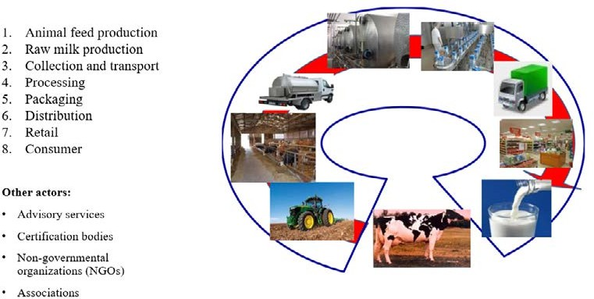

Picture 1. Dairy value chain

- https://idl-bnc-idrc.dspacedirect.org/server/api/core/bitstreams/dfcdbc99-9203-4c26-9865- 450ff6ea1fd7/content

Dairy value chain
Milk production is the dominant activity and the main product of livestock production, which is typical for Montenegrin agriculture. For several years, milk production has been relatively stable, with relatively small variations and fluctuations in quantity and type. The dominant share is cow’s milk, with around 93%, followed by sheep’s milk, with a share of 4 to 5%, and goat’s milk, whose production represents slightly more than 2% of the total balance of raw milk.
Cow’s milk: Over the past decade, milk yield per cow has been steadily improving (Sectoral Analysis, 2021). According to the data of the Livestock Selection Service, the average milk yield per cow in the controlled population in 2020 is 5,989 liters, while the estimate of the average milk production for the total population in 2020 is 3,035 liters per cow, which indicates continuous progress, although the val- ues are still below the average production in the region (Croatia 4,620 liters, Slovenia 6,200 liters) and the EU 27 (7509 liters). It is important to point out that milk production varies greatly by region. The highest productivity in milk production was recorded in the Nikšić region, where production per head is at the level of 6,981 kg, then in Podgorica and Danilovgrad, 6,886 kg, while the other centers are sig- nificantly below average. The reasons for this can be found in the greater representation of the Holstein Friesian and Simmental breeds, as well as in the decision for more intensive feeding in order to increase the amount of milk delivered to nearby processing plants. Relatively modest overall results in production were due to poor breed composition, production technology and housing conditions for animals. In order to overcome these problems, in the future support models will be aimed at solving these problems.
The production of sheep’s milk accounts for 4-5% of the total milk production. The keeping of spe- cialized, typical breeds for milk production is not represented. The practice of milking is declining, and milk collection is poorly organized and production is adapted to mountainous climatic conditions, such as in the north of Montenegro. The reason for this is the high intensity of work, lower yield and lack of
8 workforce. The sheep are taken to mountain pasture from late spring to autumn. This practice is most prevalent in the northern part of Montenegro, while in the central and southern regions, due to limited
grazing areas, some of the livestock is handed over to herders who take them to some of Montenegro’s summer, mountain pastures, katuns. The estimated average milk yield is around 90 liters (Sectoral analysis, 2021), the milk yield of sheep (according to Monstat, 2021) increased by 51% in the period 2014–2020 year (from 73 to 110 liters per head), while in the same period the average milk yield was 88 liters.
The production of goat’s milk is predominantly concentrated and important in karst areas, as well as on the coast and its hinterland. The greatest number of goats are in the area of Nikšić and Cetinje. This traditional extensive and semi-extensive production in areas where natural conditions do not allow the breeding of other ruminant species (cattle or sheep) is increasingly being replaced by modern dairy farms, where the main driver of growth is the production of quality cheeses intended for tourist and domestic supply. Market demand for goat products, which can be considered local specialties, is increasing. This production has potential. As a complementary production, the sale of goat meat can also occur, where there is also potential, if the customer is properly targeted and consistent quality and supply are established.
Milk processing: trends in the last seven years show that the process of concentration of milk processing towards the region of central Montenegro is still ongoing, when it comes to the regional representation of capacities. Almost 70% of the total purchased milk is directed there, primarily in the municipalities of Nikšić, Danilovgrad and Podgorica. The northern region of Montenegro, although significant in terms of the total livestock and the supply of milk, is focused on milk processing on family farms, while the sale of raw milk to local dairies and dairies in neighboring municipalities is equally present. Additional transportation costs certainly affect production efficiency and production results, indicating that, despite higher costs of purchasing raw materials, there is an economic interest in increasing processing volume, especially among larger farms and suppliers. The range of products in dairies has not changed significantly

in recent years, but there are visible differences in the participation of production categories, whereby the production of cheese in 2020 is 43% higher than in 2017, the production of fermented products is higher by a quarter, and the production of cream has doubled.
Milk processing in registered facilities of small producers: Considering that this sector is important for a large number of producers in rural areas, and that the placement of traditional, quality products through tourism is one of the strategic goals of Montenegrin agriculture, the Ministry of Agriculture, Forestry and Water Management decided in 2017 to support milk processors on farms with a special measure of the Agricultural Budget. The highest concentration of these producers is in the north, 85.59% in 2019, mainly in the municipalities of Pljevlja and Bijelo Polje, and 14.16% in the central part, while there was a total of 12 applicants from the southern region.
From the aspect of rural development, animal husbandry and dairying are labor-intensive and enable continuous employment of the population, as well as additional employment of female labor force, which is particularly significant in conditions of high unemployment, which affects rural areas. Relatively stable milk production is maintained by two opposite trends - the decrease in the number of small farms, which until now largely compensates for the increase in the production of larger farms, all in the combined effect of increasing the number of heads, but primarily through higher milk yield, breed composition and improved nutrition. In the following period, it is necessary to work on improving the milk yield of cows. The shortfall in production, which is mostly seasonal, is compensated by importing not only finished products but also raw milk. Yogurt and fermented milk products take third place in terms of quantity and value of milk and milk products imports in the observed period. The share of yogurt is about 15%, and other fermented products about 9%. Seasonal variations affect the turnover of raw milk, and the biggest deficit in this category is long-life UHT milk, for which there are no processing capacities. The degree of self-sufficiency in milk production in Montenegro is about 63%. Based on the total consumption of the population in Montenegro and production in 2019, it can be seen that domestic production covers 63% of milk needs. The rest is covered by imports, so decisions on import restrictions (which are also not possible due to existing free trade agreements) are not sustainable.
9
Import/export: Montenegro is an import-dependent market, with a continuously high volume of im- ported quantities of milk and milk products. The price ratio of milk and dairy products achieved in export and import shows that, in general, products with a higher level of processing are imported compared to those exported. The lack of diversification, in terms of the number and type of products that are export- ed, as well as the number of countries to which it is exported, is one of the general shortcomings of the Montenegrin industry, and this is especially true for the dairy sector. Export is sporadic, partly masking the return of products, and in no sense reflects the true picture of the lack of capacity and potential to enter other markets, especially when it comes to high-quality cheeses and recognizable authentic dairy sector products. The total value of the import of all dairy products, expressed in milk equivalent, in 2019 was about 48.8 million euros, almost 10 percent more than in 2018, while the amount in tons of imported milk in milk equivalents remained almost unchanged. Observed over a slightly longer period, the total import of dairy products is slightly decreasing, the decrease in the import of cheese was even reduced by a quarter in 2015 compared to the previous year, then it increased again, to remain at stable values for the entire period, but still overall lower by about 15% compared to the initial year, 2014. Continuously, in the observed period, the total value of the import of dairy products is dominated by two categories - non-concentrated milk (with the largest share of UHT milk) and cheese, which participate in the total import of these products with about two-thirds (in 2019, this share was 67%).
Self-sufficiency: Milk and milk products cover 5.3% (24.7 million euros) of total food imports, of which cheese accounts for 2.7% (12.4 million euros). According to FAOSTAT, the total domestic demand for milk is 260,000 tons, of which 222,000 tons are for food, 24,000 tons for animal feed and 11,000 tons for processing. Milk production ensures 67% self-sufficiency and amounts to 160,000 tons. The challenges

are in raising the yield and involving the producers in the production for the market, reducing the costs and acting together in the market with protected marks and quality schemes.
The possibilities for milk production are particularly reflected in the following:
- Development of local capacities for milk collection (private or private-public or public), storage and processing on and off the farm;
- Consolidation of production and processing capacities and strengthening of cooperation at multiple levels (clusters, LEADER, cooperation for supplying schools - school schemes, etc.);
- Development of brands, intensive marketing and promotion of Montenegrin milk, dairy products and cheeses;
- Development of sectoral operational programs that will be supported by Montenegro and later by the CAP.

Stakeholder consultation
During November 2024, 5 consultation workshops were held in the following Montenegrin municipalities:
- Nikšić (2 workshops)
- Danilovgrad
- Tuzi and
- Bijelo Polje.

Annex I contains photos from the workshops.
Workshop participants were from all parts of the value chain, starting from primary producers, through buyers, processors to sellers of final products. A certain number of representatives of interested parties, such as representatives of local administration, advisory services, non-governmental organizations and
10 associations, also attended.

The average number of participants per workshop was 15, while the gender and age structure of producers and processors is given in the table below:

Gender structure of producers and processors | 25 – women  42 – men | 1 - woman  9 – men
Age structure od producers and processors | Average age 45 | Average age 50
The participants were sent in advance, along with the invitation, a prepared agenda that contained a brief description of the problems related to the dairy value chain, as well as the proposed structure and schedule of the workshop.
In the introductory part, the participants were introduced to the concept of the value chain, especially in the milk production sector. Then topics and questions for discussion as well as proposals for possible solutions were presented.

Proposed discussion questions:
- What are the main challenges faced by farmers in the dairy value chain?
- How can farmers improve their position in this value chain?
- What are the key factors that affect the income of farmers in this value chain?
- Can farmers realistically influence decision-making in the value chain, do they have the op- portunity to negotiate, and what will affect the price of milk and their position in the value chain in general?

The above questions are divided into more specific areas as follows:
- The possibility of producing your own animal feed?
- Access to veterinary services?
- Possibility of improving production capacity? Work force?
- Access to credit lines and other forms of state support?
- Green transition (handling of manure, waste...)?
- Possibility of creating additional value (milk processing on the farm)?
- Availability and efficiency of advisory services? Access to training? Being informed?
- The possibility of connecting milk producers (cooperatives, etc.)
Proposed solutions to the problems and recommendations are presented:
- Strengthening the cooperation of milk producers (cooperatives, associations of producers, bar- riers, sectoral programs...)
- Improving cooperation in the value chain and solving bad trade practices (the role of associations, previous experience, transparency in determining the price of milk and contracting...)
- Development of market-oriented production models (diversification of production, added value of products, certification, knowledge of consumer habits and needs, practice of using digital tools...)
- Monitoring and application of research and innovation (eco-innovation, readiness for application and investment in innovation in production, availability of training, state support...).
During the workshops, a SWOT analysis was conducted together with the participants, which served the expert for its final design.

11

Results and discussion

The results of the discussion collected during the workshops can be grouped as follows.

Participants’ responses and comments on the proposed topics

What are the main challenges faced by farmers in the dairy value chain?
  - Weaknesses in communication between different actors in the value chain
  - Lack of labor on farms
  - Frequent changes in laws related to taxes and contributions (“Europe Now”)
  - Weaknesses related to the aspect of livestock selection (import of lower quality heads, poor genetic characteristics)
  - Uncertainty regarding the availability of arable agricultural areas for livestock feed production (possibility and conditions of land lease)
  - Emergence and poor control of infectious diseases
  - High trading margins
  - Difficulties in obtaining credit support (IPARD) in the sense that the procedure is compli- cated, as well as the lack of state support in providing initial funds for investments
  - The departure of young people from the rural areas due to poor financial conditions and weak infrastructure (roads, schools, etc.)
  - Lack of farmers’ voice in parliament
  - Frequent personnel changes in the relevant Ministry, party influence on decision-making, insufficient allocation in the budget for agriculture
12 xii. Resistance of some farmers to association

How can farmers improve their position in this value chain?
  - Reduction of production costs
  - Implementation of standards (product quality, equipment)
  - Association

What are the key factors that affect the income of farmers in this value chain?
  - High and unstable livestock feed prices
  - Uncontrolled import of milk and milk products
  - Poor access to veterinary services and high prices for those services

Can farmers realistically infiuence decision-making in the value chain, do they have the oppor- tunity to negotiate, and what will affect the price of milk and their position in the value chain in general?
  - Poor position of farmers when determining the purchase price of milk (impossibility to influence the formation of the purchase price)
  - The appearance of the formation of dumping prices by sellers
  - Insufficient number of associations of primary producers that would negotiate with other actors in the value chain
  - Monopolistic behavior of milk buyers

Proposals and suggestions from workshops’ participants
During the workshops, suggestions for solving problems were collected and can be grouped into the following 4 groups:

Strengthening milk producers’ cooperation
  - Connecting actors in the value chain
  - Greater political representation of producers and processors, increasing their visibility, joint lobbying
  - Joint representation towards state bodies in order to improve and pass regulations (Law on Agricultural Land, Law on Breeding Registry/Civil Registry Law. Reaching an agreement with the state on key issues
v. Informal association of farmers in order to purchase and use common equipment

Improving cooperation in the value chain and solving bad trade practices
  - Joint approach to large retail chains
  - Associating farmers when negotiating with other actors in the value chain
  - Stimulation of young producers by the state
  - Introduction of anti-dumping duties by the state
  - Increase the availability of domestic products in retail chains
  - Flat rate taxation of small producers instead of fiscalization

Development of market-oriented production models
  - Introduction of standards in production and processing
  - Improving the work of the certification body for organic production 13

Monitoring and application of research and innovation
  - Introduction of green energy sources on farms
  - Improvement of waste management on farms
  - Diversification of farming activities (traditional products, rural tourism)
  - Strengthening prevention in the field of veterinary protection
  - Increase the number of trainings and make them available to farmers
  - Adopt good practices from other countries regarding the occurrence and control of infectious diseases (Q fever)
  - Raising the awareness of producers in the field of green energy and environmental protection, introducing campaigns to support farmers (Five honest/ Five Fair)
  - Improving the education of agricultural producers (secondary agricultural schools), training for the business plan development
  - Scholarships for veterinary students
  - Improvement of the work of advisory services, especially at the municipal level
  - Introduction of registry service

SWOT analysis

STRENGTHS
- The existence of a market (local and through the tourist offer) for domestic products
- Preserved environmental quality
- Preserved values and knowledge in the production of local traditional products
- Short delivery channels of products to consumers (local consumption)

WEAKNESSES
- Insufficient competitiveness of domestic production
- Poor rural infrastructure
- Aging of the active workforce
- Weak association of milk producers, insufficiently affirmed and developed clusters and associations
- Numerous inherited difficulties (milk producers are not always ready to cooperate, mutual distrust, negative image of cooperatives)
- Depopulation of rural areas

OPPORTUNITIES
- Favorable conditions for organic production
- Access to advantageous financing instruments (IPARD, IFAD)
- Opportunity for recognizable Montenegrin products placement on the market
- Tourism - a driving force for agricultural and rural development through “doorstep” exports and the possibility to absorb seasonal surpluses of milk and dairy products
- Significant space for the dissemination of knowledge, innovations, and application of innovative
14 technologies

THREATS
- Competition from imported products
- Insufficient support from the banking sector to small farms
- Infectious diseases
- Climate changes (floods, droughts...)

Conclusions

This report, using value chain analysis, provides a summary of the current state of the dairy production sector in Montenegro and proposals for improvement measures. The previous chapters present the summarized results of discussions with identified challenges obtained during workshops with farmers and other stakeholders in the value chain, held in 5 Montenegrin municipalities, covering the northern, central, and southern regions.
Based on the comprehensive value chain analysis, all identified recommendations and expected out- comes, the main recommendations are provided, and the next actions are defined in order to improve the competitiveness of the dairy value chain.

The main recommendations for improvement can be grouped as follows, as stated in chapter 4.2:
- Strengthening the cooperation of milk producers
- Improving cooperation in the value chain and solving bad trade practices
- Development of market-oriented production models
- Monitoring and application of research and innovation.

15

Recommendations based on the SWOT analysis

Based on the inputs collected during workshops with farmers, a SWOT analysis was conducted to further identify the external and internal factors affecting the dairy production chain in Montenegro.
The recommendations obtained from the SWOT analysis can be grouped as follows:

Recommendations to farmers
  - Focus on organic production in areas where suitable conditions exist
  - Preserving traditional and recognizable products and promote them
  - Orientation towards available favorable sources of financing (IPARD, IFAD...)
  - Connecting with the tourism sector in order to improve product placement
  - Involvement in existing forms of farmers association (clusters, associations)
  - Participation in available training programs, exchange of good practices, etc.

Recommendations for relevant institutions and stakeholders
  - Support for the association of producers
  - Improvement of legal regulations
  - Increase incentives for preserving domestic production and reducing dependence on imports
  - Improvement of living conditions in the countryside through investment in infrastructure
  - Special support programs for young farmers
  - Improvement of the capacity of advisory and veterinary services.
16

Messages from the Conference, at which the National report was presented

The conference “Strengthening the role of farmers in the value chain - together to a sustainable green transition” was held on December 23, 2024 in Nikšić, where a national report was presented, that in- cluded the results collected during the consultative workshops. The well-attended conference was joined by farmers from all parts of Montenegro, as well as representatives of the relevant Ministry, the Food Safety Administration, the Municipality of Nikšić, the academic community, the Agricultural Cluster of Montenegro, representatives of the dairy industry, the Advisory Service, as well as non-governmental organizations and representatives of the media.

The key messages received during the conference are as follows:
- Association of farmers is a necessary condition for strengthening their position in the dairy value chain in Montenegro;
- The political representation of farmers in the parliament would strongly contribute to making their voice heard better, as well as helping to solve problems related to the improvement of legal regulations, the increase of the agricultural budget, more efficient work of administrative bodies dealing with the department of agriculture;
- Promotion of domestic autochthonous breeds in milk production;
- The role of the media is one of the key factors that needs to be improved, and it is necessary to work on the education and specialization of journalists.

Annex II contains photo documentation and media coverage from the National Conference.
17

Reference

- Strategy for the development of agriculture and rural areas 2023-2028
- Statistical yearbook of Montenegro, 2023.
- Farm to Fork Strategy
- Value Chain Analysis in the Montenegrin Dairy Sector, European Training Foundation, 2013
- Sustainable agriculture and the food value chain, Ministry of Science, 2018.

Note: The content of this Report is the sole responsibility of the NGO Network for Rural Development of Montenegro and does not necessarily reflect the views of the European Union or the Ministry of Public Admin- istration of Montenegro.

18

Annex I

Photo documentation from the workshops

19

- Consultative workshop in Nikšić, November 6th 2024

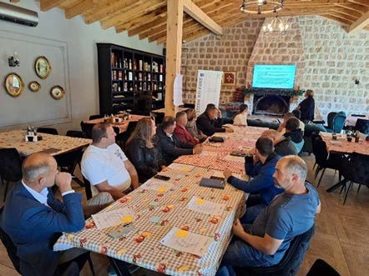

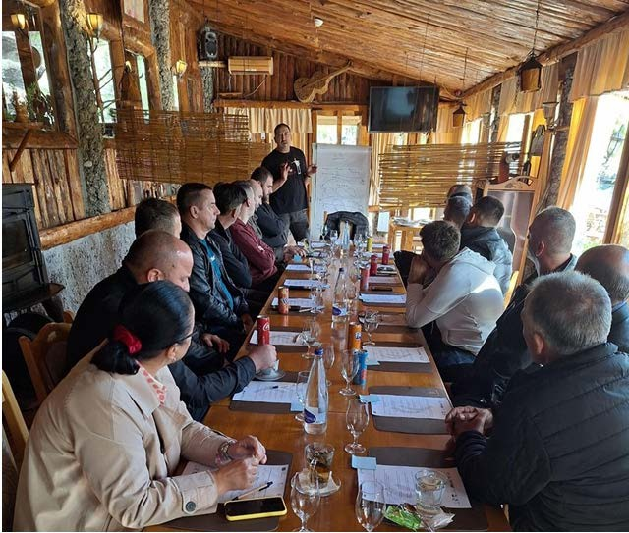
Consultative workshop in Tuzi, November 7th 2024

20

Consultative workshop in Nikšić, November 8th 2024
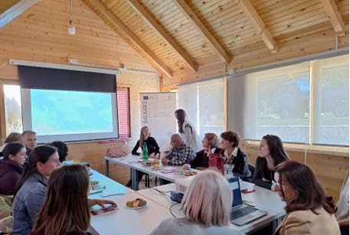

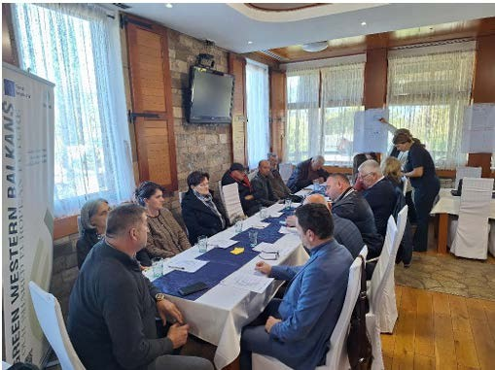
Consultative workshop in Danilovgrad, November 11th 2024

21

Consultative workshop in Bijelo Polje, November 12th 2024
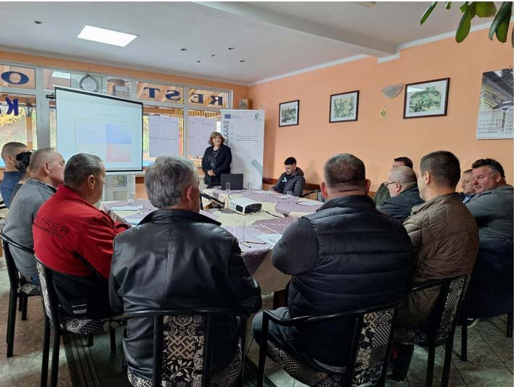

22

Annex II
National Conference - photo documentation ²³
and media coverage

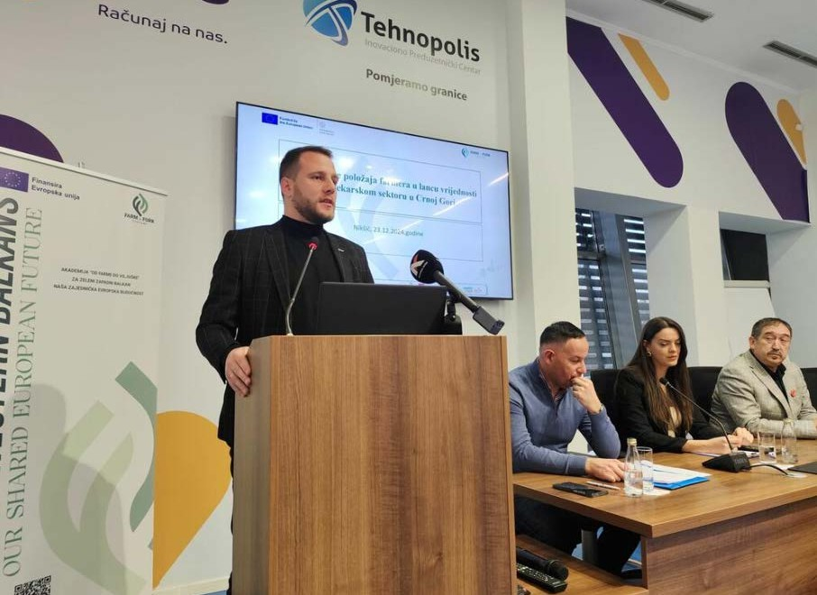
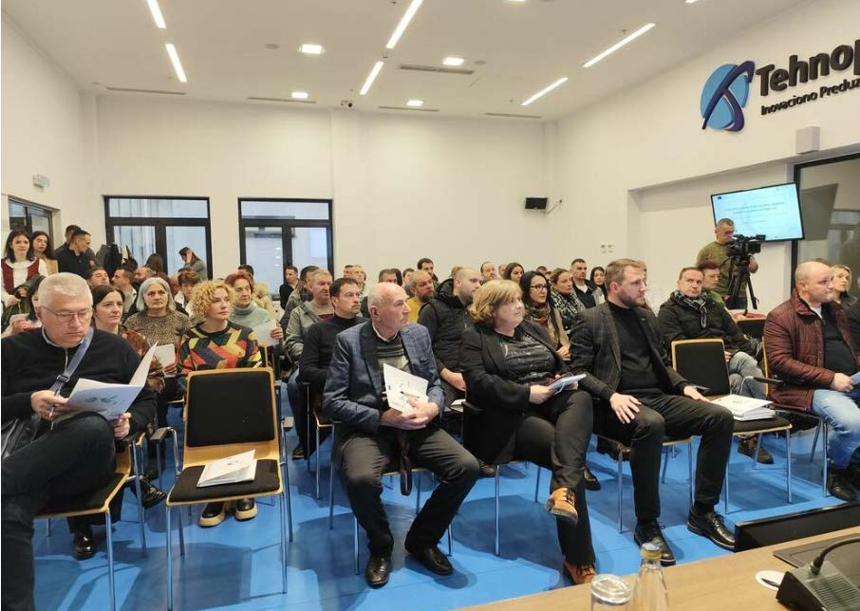
24

Media coverage from the Conference

Daily newspaper and portal Vijesti:
https://www.vijesti.me/vijesti/ekonomija/738159/djuranovic-svakoga-dana-28-miliona-eu-
ra-ode-iz-crne-gore-na-uvoz-hrane-i-pica?fbclid=IwY2xjawIIVcJleHRuA2FlbQIxMQABHU7tBM- TAeDW4-jwYhxdvic07DRKNX8t1v2bdtWrHyLlIUH7FzlpCvhKEMQ_aem_t4iMsPl5Di46cveg- sOYHRw&sfnsn=mo

Daily newspaper Dan:
https://www.dan.co.me/crna-gora/predstavljeni-rezultati-projekta-od-farme-do-viljuske-dura- novic-na-uvoz-hrane-svakog-dana-ode-2-8-miliona-5276221

RTV Nikšić:
https://rtnk.me/drustvo/video-tehnopolis-predstavljeni-rezultati-projekta-od-farme-do-viljuske/

Portal Onogošt:
https://onogost.me/biznis/drzava-trgovci-i-potrosaci-da-pomognu-farmerima/?fbclid=IwY2xjawI- JpptleHRuA2FlbQIxMQABHVOcpcpdGlUfOEgkpdeQKVSMhdJRb0rbkj0FVnxcT6hwT6gI6VrH- FMRkRg_aem_xvaJcNfuH0sUNMLJ928Gwg&sfnsn=mo

25

Note

26

